1. Get the styling as per the image using only css combinators

<!DOCTYPE html>

<**html**>

<**head**>

<**style**>

</**style**>

</**head**>

<**body**>

<**p**>A</**p**>

<**div**>

<**p**>B</**p**>

</**div**>

<**p**>C</**p**>

<**p**>D</**p**>

</**body**>

</**html**>

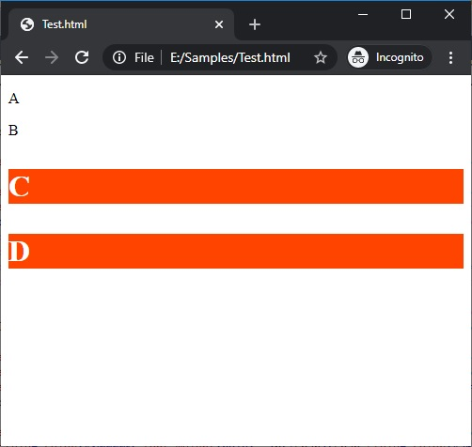

1. Get the output as seen in the image for the following code. Use appropriate selectors and combinators to get the desired output.

<p>I am the first p</p>

<div class='container'>

<p>I am the second p</p>

<div>

<p>I am the third p</p>

</div>

</div>

<p>I am the last p</p>

<p>I am the very last p</p>

